**CST8117 Project 1: Simple Client Website with Constraints**

**Style guide**

Student: Elena Khrychenkova

Contents

Client 3

Style 3

Semantic Design Guide 4

Website Map 8

References: 9

## Client

My client is a local plant shop which focuses not only on selling the indoor plants, but also on providing services such as planting, plant healing and plant decor consultations.

Potentially client might decide to add a block section to their web site to make it not only a platform to sell their services, but also to provide some essential information on taking care of the plants and tips to make this care easier and more effective.

## Style

My client wants me to create a website which will be consistent with their in-person shop style. This is a light place with an accent on deep the green colour. The client sticks to the leaves images since their shop is named after the monstera plant which has large leaves. Overall impression from the website is expected to be minimalistic and monochromic with a bright accent on green.

In addition, client provided us with the logo they desire to see on the top of their website.

Some examples:

* <https://plantscoach.ru/>
* <https://www.plantandcurio.com/>
* <https://zigansha.com/>

As per discussion with the client, the website will target traditional monitor resolution of 1024X768.

## 

## Semantic Design Guide

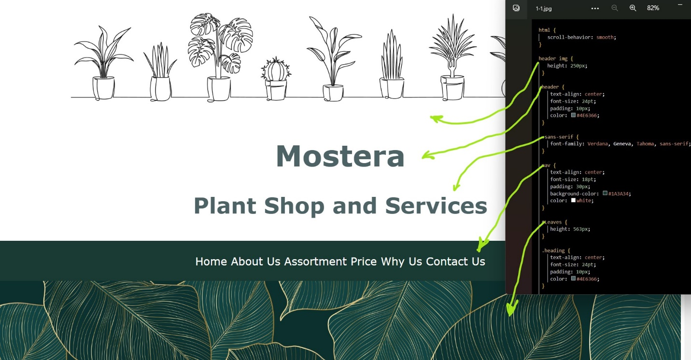

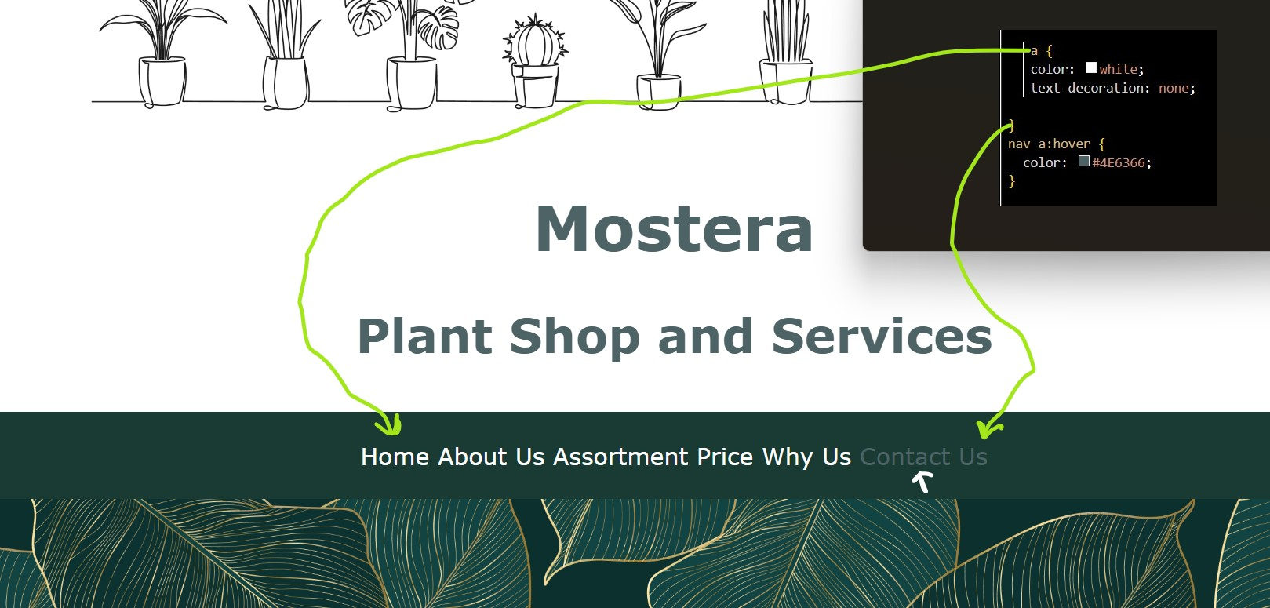

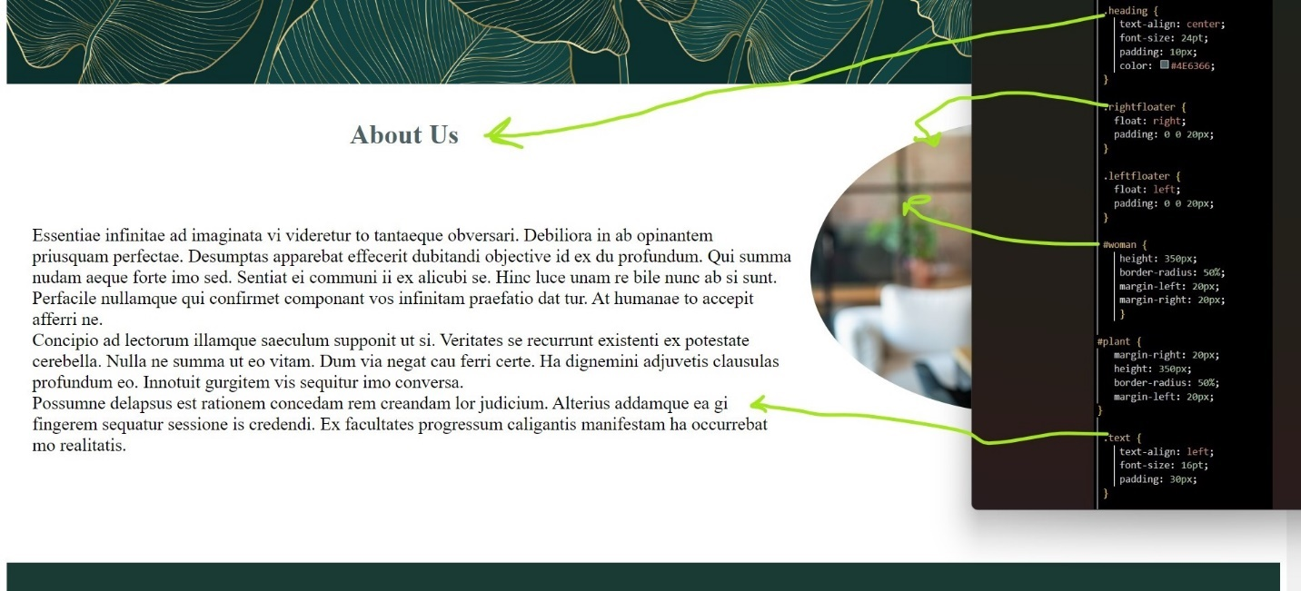

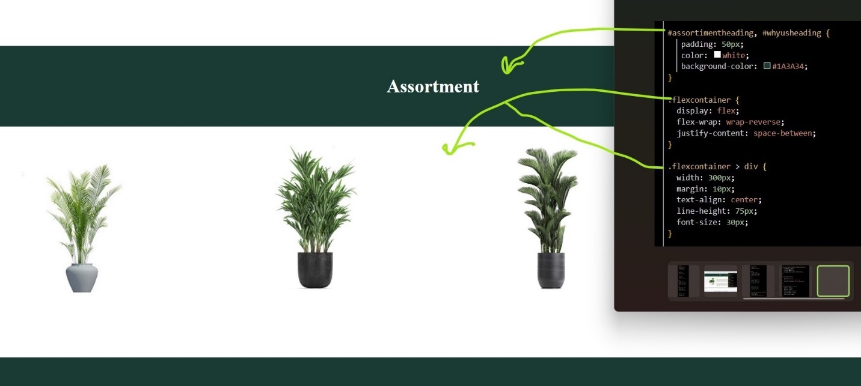

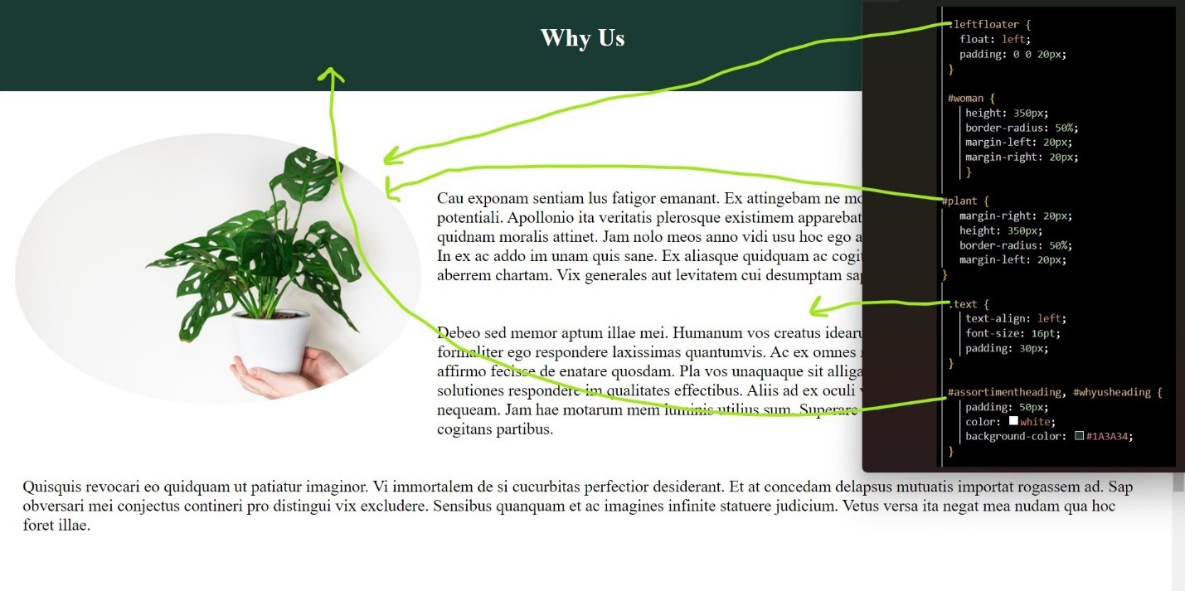

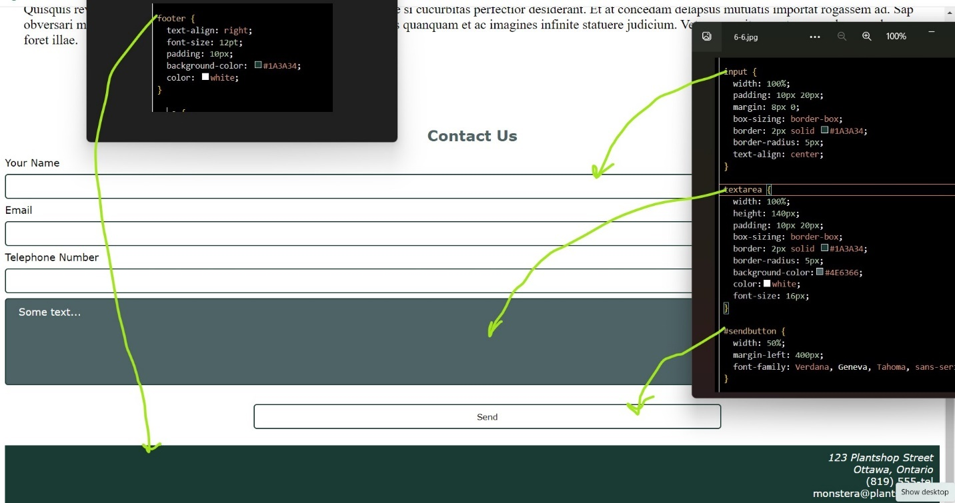

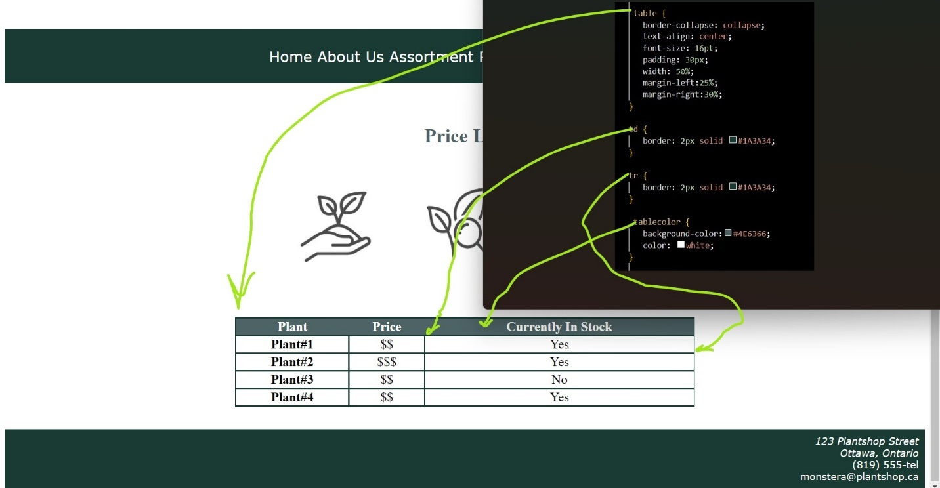

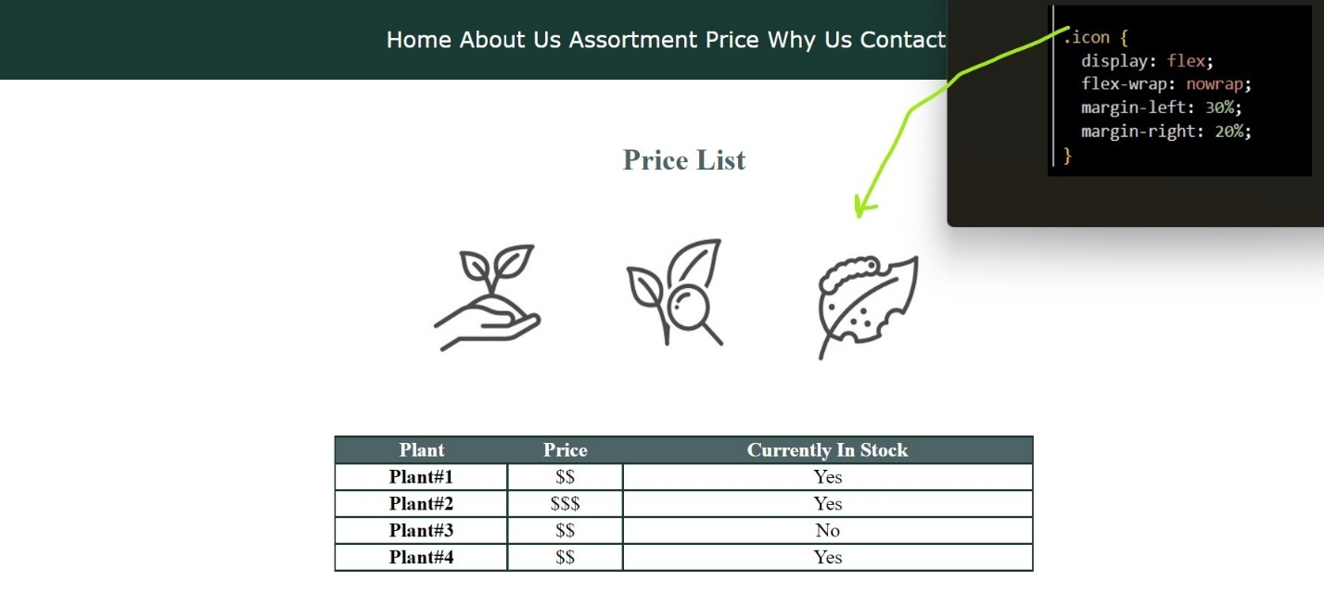

## Website Map

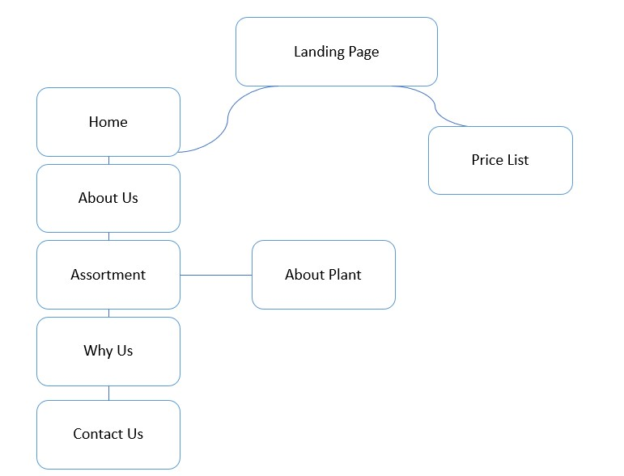

## References:

1. CST8117 _Labs 1-4 retrieved from [Homepage - 22F_CST8117_010_011_012_013 Cross-Platform Web Design (algonquincollege.com)](https://brightspace.algonquincollege.com/d2l/home/461709)
2. All images retrieved from <https://www.shutterstock.com/>
3. <https://www.w3schools.com/>
4. Website text generated from <https://randomtextgenerator.com/>